## Accessing the Registry

**Type regedit in Start→Search**

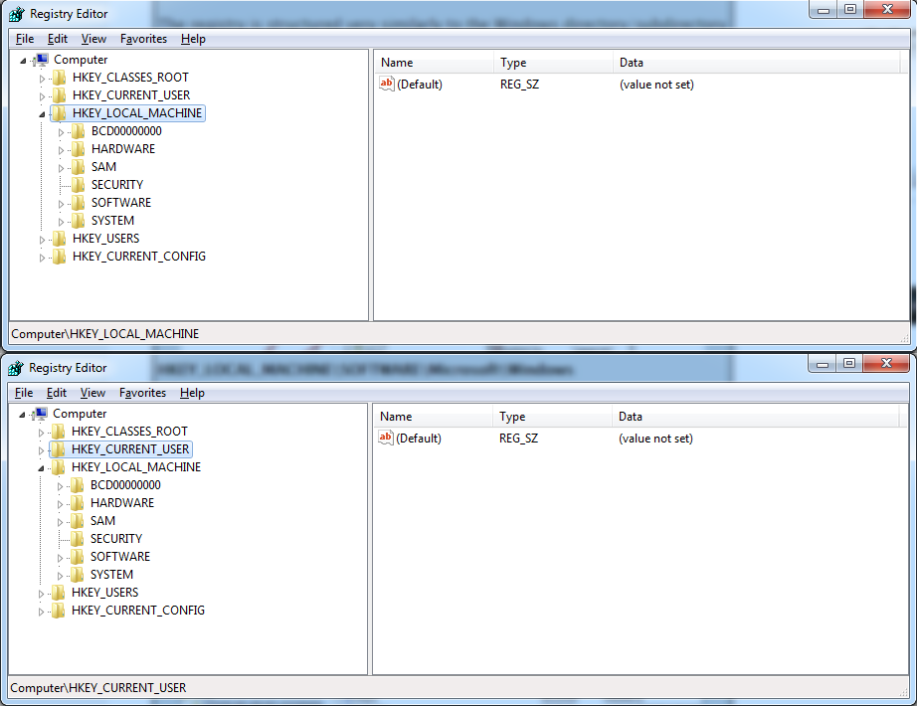

**Wireless Evidence in the Registry HKEY_LOCAL_MACHINE\SOFTWARE\Microsoft\WindowsNT\CurrentVersion\NetworkList\Profi les**

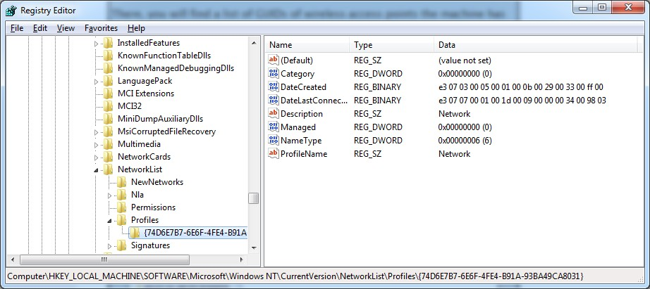

## The RecentDocs Key

**HKEY_CURRENT_USER\Software\Microsoft\Windows\CurrentVersion\Explorer\RecentDocs**

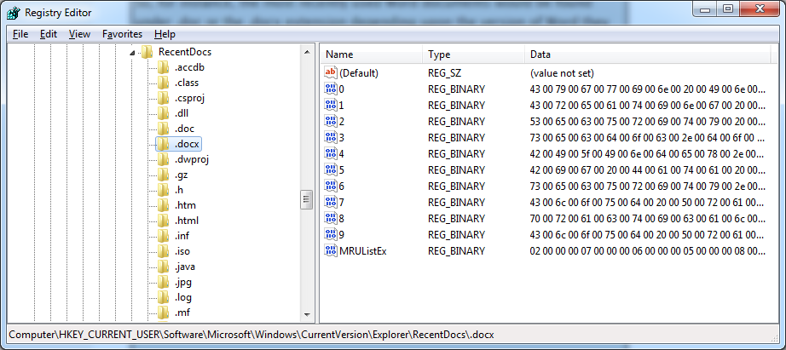

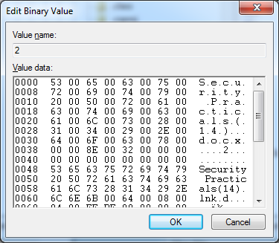

**TypedURLs Key**

**HKEY_CURRENT_USER\Software\Microsoft\Internet Explorer\TypedURLs**

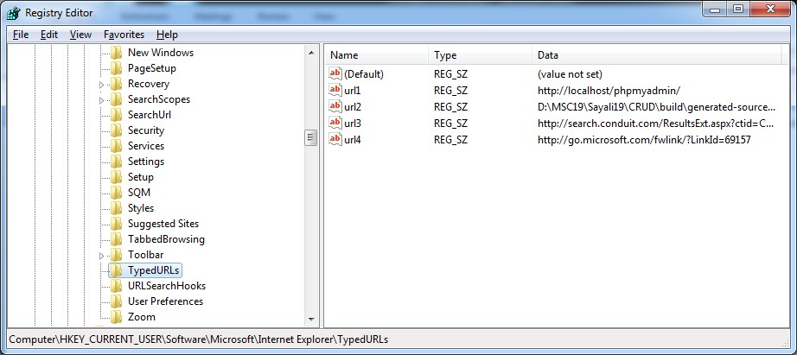

**IP Addresses HKEY_LOCAL_MACHINE\System\Services\CurrentControlSet\services\Tcpip\Parameters\Interface s**

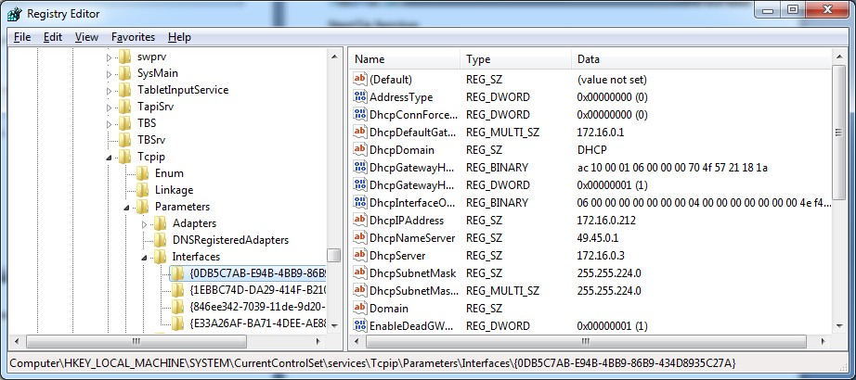

**Start Up Locations in the Registry**

**HKEY_LOCAL_MACHINE\Software\Microsoft\Windows\CurrentVersion\Run**

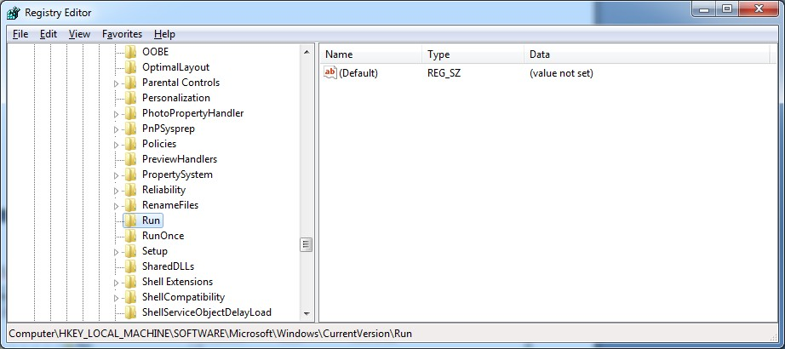

**RunOnce Startup**

**HKEY_LOCAL_MACHINE\Software\Microsoft\Windows\CurrentVersion\RunOnce**

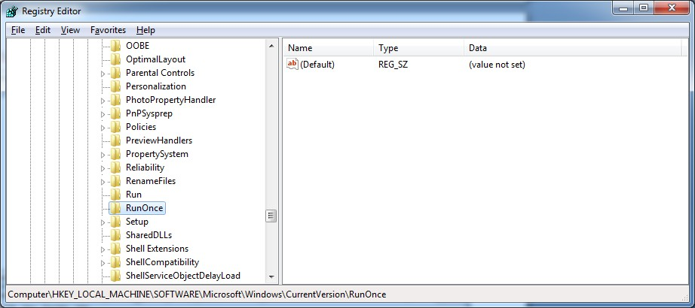

**Start Up Services**

**HKEY_LOCAL_MACHINE\System\CurrentControlSet\Services**

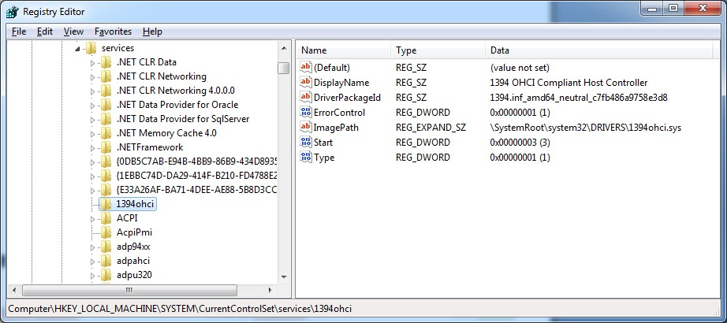

**Start Legacy Applications**

**HKEY_LOCAL_MACHINE\System\CurrentControlSet\Control\WOW**

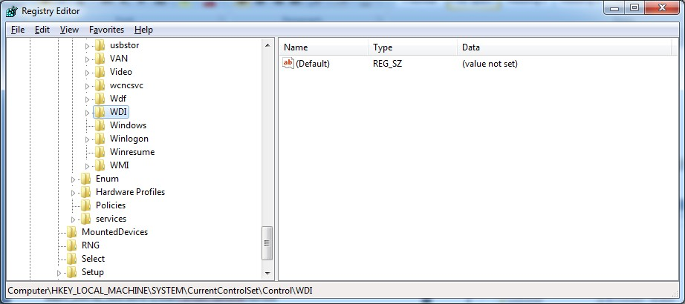

**Start When a Particular User Logs On**

**HKEY_CURRENT_USER\Software\Microsoft\Windows\CurrentVersion\Run**

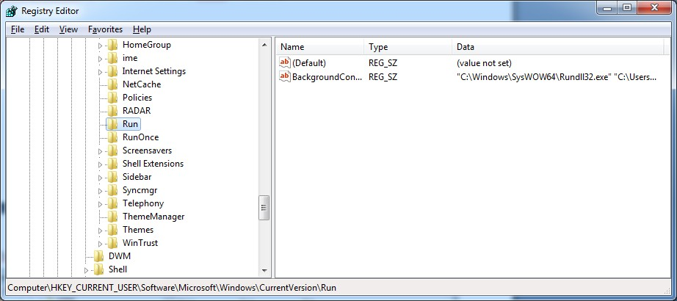

**USB Storage Devices**

**HK_Local_Machine\System\ControlSet00x\Enum\USBSTOR**

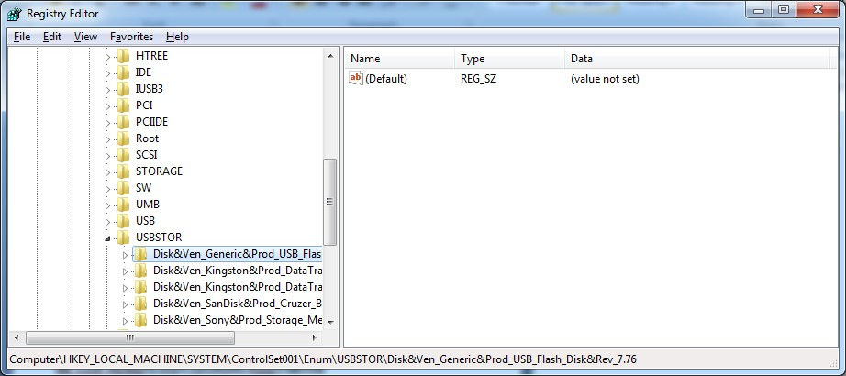

**Mounted Devices**

**HKEY_LOCAL_MACHINE\System\MountedDevices**

